1. Start Reflection Workspace

"C:\Users\demo\AppData\Local\Micro Focus\RSC\Reflection Flight.rd3x"

1. In Reflection Workspace, Settings, Configure Advanced Reflection Settings, to set a Short Name (I used B) and compatibility set to Reflection.

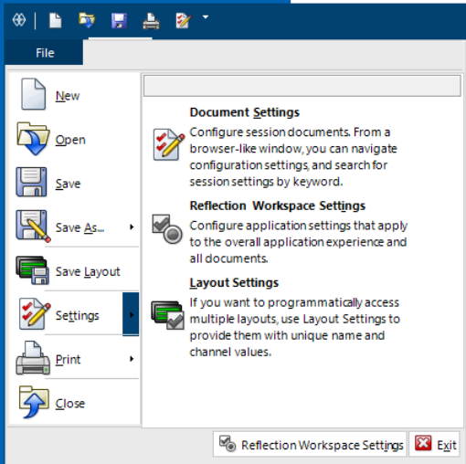

Click on the Settings itself, not on one of the three options that pop-up on the right.

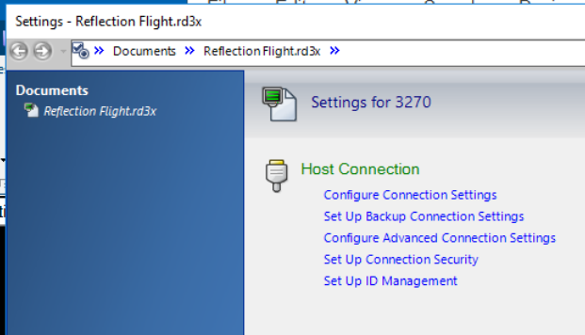

Note in the below that the scroll bar is all the way at the bottom. There is where the hllapi Short Name is set.

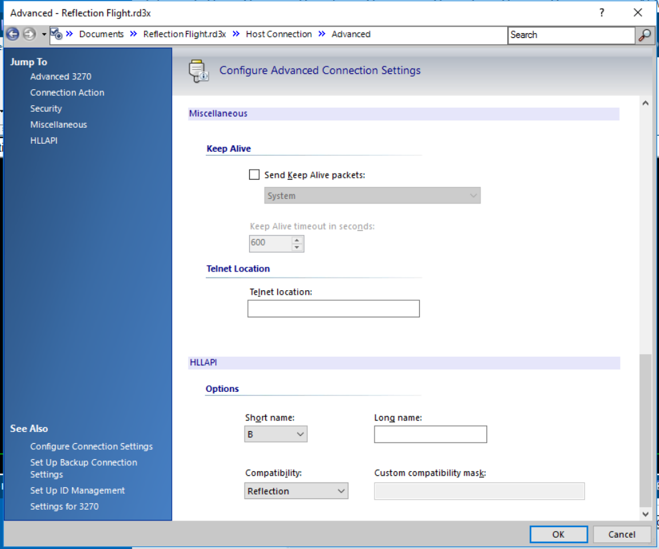

1. Launch UFT 14.53, selecting the Terminal Emulator add-in and create a new Test (or load one).
2. Open a code tab (showing VBScript) and select Tools > Options. (as opposed to Start Page, Results or the Test Flow pane)
3. Select GUI Testing > Terminal Emulator
4. Set Vendor to:                  Attachmate (WRQ)
5. Set Emulator to:               Reflection
6. Set Protocol to:                 Auto-Detect
7. Click the Validate button – it should display a green OK.
8. Also, under the Adjust Configuration button, you should have these settings:
   1. HLLAPI dll file:                    C:\Program Files (x86)\Micro Focus\Reflection\hllapi32.dll
   2. HLLAPI function name:  hllapi
   3. Argument size:                 word (16 bit)
   4. Warn if HLLAPI dll file not found is checked
   5. Object Identification Settings:    Identify Screen Label using all characters
   6. Record Mode:                   Context Sensitive
   7. Record Cursor Position checked
   8. Trim trailing spaces in fields checked
   9. Use property patterns checked
   10. Beep when sync operations are performed checked